- Recent data have tilted the risks in favour of faster UK interest rate cuts, though we don't think the situation is quite as clear-cut as markets believe. The Monetary Policy Committee's middle ground scenario, where some spare capacity is needed to fully normalise price- and wage-setting behaviour, is likely to remain the most popular narrative for most MPC members.
- September's low inflation outturn was in line with our expectations and should prove a blip, with fading base effects and a rise in the energy price cap causing inflation to rebound in October. Our proprietary high-frequency sentiment dataset points to a more abrupt slowdown in pay growth than official data and suggests that labour market conditions are continuing to loosen.
The final set of labour market and inflation data before the November Monetary Policy Committee meeting triggered a dovish reaction from financial markets. A November rate cut has long looked like a done deal, but whether the MPC went for another cut in December was much less certain – at the end of last week, markets priced 36bps of cuts by the December meeting, implying it was around a 50/50 chance that there would be successive rate cuts. By Thursday, that probability had risen to just under 70%.
September's CPI reading of 1.7% was in line with our expectations and reflected two factors that were well-flagged ahead of the release. First, strong base effects, caused by an unusually high reading for services inflation last September. And second, a big drop in the contribution of the petrol category, again partly caused by base effects but also due to pump prices falling by nearly 4% between August and September.
Markets reacted strongly because the outturn for services inflation (4.9%) was much lower than the 5.5% forecast by Bank of England staff in August's Monetary Policy Report. However, while these forecasts were central to monetary policy judgements last year, those who voted to cut in August made clear that they are now adopting a more forward-looking approach and placing a smaller weight on these backward-looking indicators. Moreover, the two previous outturns had also undershot the BoE staff forecast, albeit to a smaller extent. Markets might be overplaying the importance of this comparison.
Chart 1: Monthly growth in services prices is running close to pre-pandemic norms
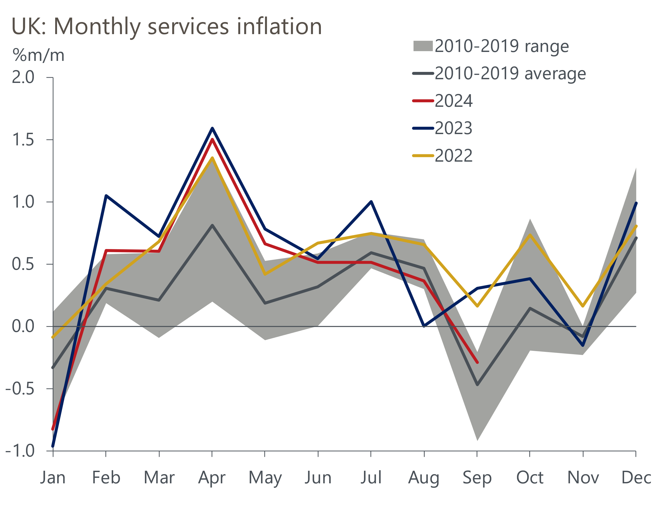
Source: Oxford Economics calculations using data from Haver Analytics

For much of 2023 and the early part of 2024, services prices were rising much faster than pre-pandemic norms on a month-on-month basis (Chart 1). Indeed, they were often rising much faster than the highest equivalent monthly reading from 2010-2019. But through the summer, the monthly changes have been broadly in line with the pre-pandemic median. This is clearly good news and consistent with the MPC making policy less restrictive, though it's not clear they would consider price pressures merely normalising as enough evidence on its own to justify faster rate cuts.
The base effects will reverse over the next few months because upward pressures on services prices temporarily softened in late-2023. So services inflation seems likely to stabilise at around 5% over the next few months. With October's 10% increase in the energy price cap coming into play, CPI inflation is likely to rebound, climbing to around 2.5% by the end of the year and staying at that rate in early-2025.
Arguably the data on pay growth offers more compelling backing for faster rate cuts. The BoE's preferred measure, private sector regular pay, continues to cool. Headline (three-month average of the annual rate) pay growth dropped to 4.8% in August, with the three-months-on-three-months annualised rate – a better guide to recent momentum – marginally lower at 4.6% (Chart 2).
Chart 2: Private sector regular pay growth continues to gradually cool
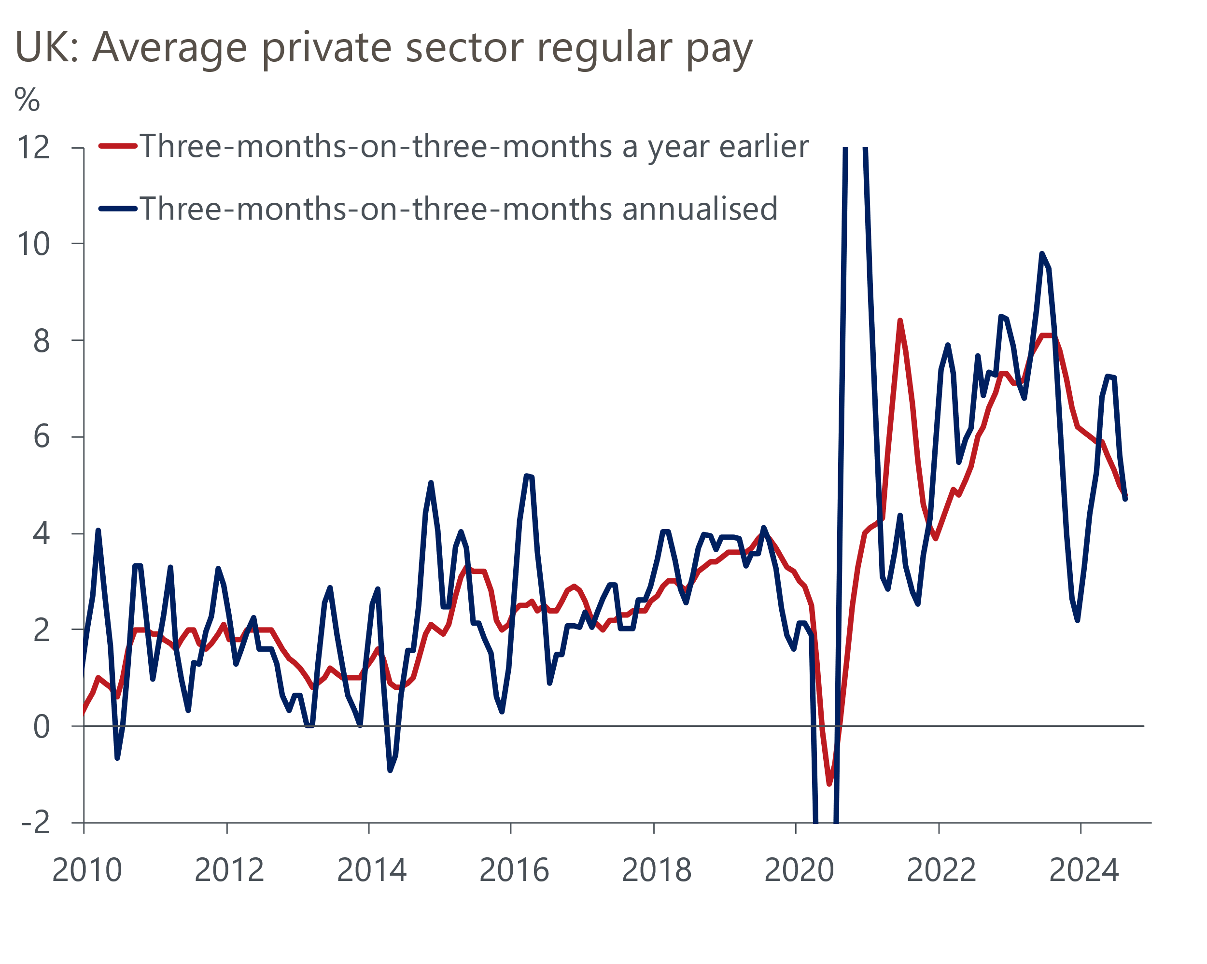
Source: Haver Analytics
But our proprietary high-frequency sentiment dataset, developed in collaboration with Penta, reports a steep decline in sentiment around remuneration. As a result, our nowcast suggests that the official measure of pay growth could slow further over the coming months. The sentiment data also suggests that labour market conditions are probably loosening, in contrast to the picture from the Office for National Statistics' troubled Labour Force Survey. Demand for labour is continuing to weaken, though firms appear to still place a high value on retaining existing staff.
Several MPC members are due to speak next week, including three of the internal members whose votes are likely to prove pivotal, so we may discover more about how they've interpreted recent data. But we suspect they will be fairly non-committal, waiting for news from the Budget and the BoE's upcoming forecast round before firming up their views.
In the minutes of recent meetings, the MPC has sketched out three scenarios for inflation, ranging from underlying pressures dissipating rapidly without a significant rise in unemployment, to one where global shocks have caused structural changes in price- and wage-setting, meaning that high inflation will persist unless the jobless rate rises significantly. For most members, we expect recent data will tilt the balance of risks towards the more benign scenario. However, the middle ground – where a period of below-potential output growth is needed to fully normalise pay and price-setting dynamics – is likely to remain the most popular. While this scenario is consistent with a steady pace of rate cuts, it wouldn't necessarily preclude back-to-back cuts at some point over the next six months.

The week ahead
Next week's only Office for National Statistics release is the public finances data for September. Recent releases have shown borrowing overshooting the Office for Budget Responsibility's March forecast due to higher-than-expected spending. With Chancellor Rachel Reeves' recent review finding that these overshoots will continue for the remainder of the fiscal year, we expect public sector net borrowing of £17bn in September, nearly £2bn above the OBR's projection.
Most surveys of business and consumer sentiment reported deteriorating confidence in September, with the survey compilers relating the weaker results to the government's messaging around the economic outlook and the prospect of tax rises in the Budget. If that explanation is right then there's a good chance that sentiment will have rebounded in October. The government has attempted to present a more upbeat view of the economic outlook, while media speculation on the Budget has centred on looser fiscal rules that will allow more investment. We expect the flash composite PMI to rise to 53.3, regaining much of September's fall, with GfK's consumer confidence index rising to -15.
Table 1: Week ahead calendar
Date | Events | Period | Measure | Unit | Previous | Forecast
Oct 22 | Public finances | Sep | PSNB ex | £bn | 13.7 | 17.0
Oct 24 | S&P Global manufacturing | Oct | PMI | % bal | 51.5 | 52.2
Oct 24 | S&P Global services | Oct | PMI | % bal | 52.4 | 53.0
Oct 24 | S&P Global composite | Oct | PMI | % bal | 52.6 | 53.3
Oct 25 | GfK consumer confidence | Oct | Headline | % bal | -20 | -15
Source: Oxford Economics

Key forecasts
Table 2: UK forecast overview
(Annual percentage changes unless specified)
 | 2022 | 2023 | 2024 | 2025 | 2026 | 2027
GDP | 4.8 | 0.3 | 1.0 | 1.5 | 1.6 | 1.7
Private consumption | 7.3 | 0.5 | 0.8 | 1.9 | 1.8 | 1.6
Fixed investment | 5.1 | -0.1 | 0.6 | 1.3 | 2.5 | 2.1
Government consumption | 0.6 | 0.6 | 2.3 | 1.9 | 1.5 | 1.5
Exports of goods and services | 12.6 | -2.2 | -0.8 | 3.0 | 1.9 | 1.6
Imports of goods and services | 13.0 | -3.4 | 2.8 | 3.1 | 2.5 | 1.7
Industrial Production | -6.4 | -1.2 | -0.8 | 1.0 | 1.2 | 0.9
Consumer prices | 9.1 | 7.3 | 2.5 | 2.5 | 2.3 | 2.1
Unemployment rate (%) | 3.9 | 4.0 | 4.3 | 4.3 | 4.1 | 3.9
Current a/c balance (% of GDP) | -2.2 | -2.0 | -2.9 | -2.8 | -2.9 | -2.8
Government balance (% of GDP) | 4.1 | 4.9 | 3.7 | 2.8 | 2.1 | 1.4
Cen. bank policy rate (%, EOP) | 3.50 | 5.25 | 4.75 | 3.75 | 2.75 | 2.00
10yr govt. bond yield (%, EOP) | 3.67 | 3.54 | 4.00 | 3.75 | 3.24 | 2.85
Exchange rate (US$ per £, EOP) | 1.20 | 1.27 | 1.31 | 1.32 | 1.32 | 1.33
Exchange rate (euro per £, EOP) | 1.13 | 1.15 | 1.19 | 1.18 | 1.18 | 1.17
Source: Oxford Economics
Table 3: Quarterly forecasts for the UK
 | 2024 |  |  |  | 2025
 | Q1 | Q2 | Q3 | Q4 | Q1 | Q2 | Q3 | Q4
GDP (% year) | 0.3 | 0.7 | 1.1 | 1.9 | 1.6 | 1.5 | 1.6 | 1.5
CPI inflation (% year) | 3.5 | 2.1 | 2.1 | 2.4 | 2.5 | 2.3 | 2.6 | 2.5
Bank Rate (%, EOP) | 5.25 | 5.25 | 5.00 | 4.75 | 4.50 | 4.25 | 4.00 | 3.75
10yr gilt yield (%, EOP) | 3.95 | 4.17 | 4.00 | 4.00 | 3.98 | 3.92 | 3.84 | 3.75
US$ per £ (EOP) | 1.26 | 1.26 | 1.34 | 1.31 | 1.31 | 1.32 | 1.32 | 1.32
Euro per £ (EOP) | 1.17 | 1.18 | 1.20 | 1.19 | 1.19 | 1.19 | 1.19 | 1.18
Source: Oxford Economics

Latest Country Economic Forecast:
October 15, 2024

Recent publications

Data Insights
September's data confirm a strong Q3 for retail sales
CPI inflation temporarily dipped in September
Cooling pay growth keeps BoE on track to cut in November
The economy returned to growth in August
Services PMI points to healthy, albeit slower, GDP growth in Q3

Research Briefings
Can PSNW be used for a fiscal rule?
Why business investment is poised to pick up
Looser labour market could pave the way for faster rate cuts
How changing the debt rule could shape the Budget
MPC takes a breath, but cuts likely to resume in November

Contacts

Oxford Economics' UK team
- Andrew Goodwin - Chief UK Economist - agoodwin@oxfordeconomics.com
- Edward Allenby - UK Economist - eallenby@oxfordeconomics.com

